**NAME -RUPSA RUPA PRIYADARSHINI OJHA**

**Position- Web Development Intern**

**PROJECT ON FACE LOGIN**

**Table of Contents**

1. Abstract 2
2. Introduction 3
3. Benefits of Face Login 5
4. Requirements 6
5. Purpose 7
6. Tools and Technologies Used 9
7. Code 11
8. Working of the FaceLogin

(Screenshots) 13

1. Conclusion 15

**ABSTRACT:**

Abstract: The face login project aims to develop an authentication system that ensures secure and user-friendly access using face detection and recognition techniques. This project leverages computer vision algorithms and machine learning models to enable users to authenticate themselves by verifying their identity through facial features. The project employs a face detection algorithm, such as the Haar cascade classifier, to accurately detect and locate human faces within images or video streams. Once a face is detected, a face recognition system compares the detected face with a pre-registered database of authorized users. This database stores user-specific data, including facial templates or embeddings, for authentication purposes. Real-time camera or video input is utilized to capture images or video frames, enabling users to initiate the face login process. A user interface facilitates user interaction by displaying authentication results and providing guidance throughout the login process. Robust error handling mechanisms ensure effective management of various scenarios, including detection or recognition failures, providing informative feedback to users. To maintain a secure face login system, appropriate security measures are implemented. The face login project demonstrates the practical application of face detection and recognition technologies, highlighting their potential for enhancing security measures and user experiences. It serves as a foundation for further research and development in the field of biometric authentication systems and can be adapted to meet specific requirements in domains such as access control, banking, or e-commerce applications.

**Introduction:**

The face login project introduces an innovative approach to user authentication by leveraging face detection and recognition technologies. Traditional methods of authentication, such as passwords or PINs, can be susceptible to security breaches and user inconvenience. Face login offers a more secure and user-friendly alternative by utilizing computer vision algorithms and machine learning models to verify user identities based on their facial features. Authentication systems based on face detection and recognition have gained significant attention in recent years due to advancements in computer vision and deep learning techniques. These systems have found applications in various domains, including access control, mobile devices, online banking, and e-commerce platforms. By harnessing the unique characteristics of an individual's face, face login systems provide a robust and convenient method of user authentication. The core functionality of the face login project revolves around two main components: face detection and face recognition. Face detection algorithms, such as the Haar cascade classifier, are employed to detect and locate human faces within images or video streams. Once a face is detected, face recognition techniques compare the detected face with a pre-registered database of authorized users. This comparison process involves analyzing facial features, identifying key landmarks, and generating facial embeddings or templates for accurate authentication. The project utilizes real-time camera or video input to capture images or video frames, allowing users to initiate the face login process. A user interface guides users through the login process, displaying authentication results and providing feedback on successful or unsuccessful login attempts. To ensure system security, encryption techniques are employed to protect user data, and measures are taken to prevent unauthorized access or tampering with the authentication system. The face login project not only focuses on security but also prioritizes user experience. By eliminating the need for traditional authentication methods like passwords or PINs, face login offers a seamless and intuitive way for users to access systems or applications. It enhances convenience while maintaining high levels of security, making it an ideal choice for modern authentication requirements.

**Benefits of Face login in the above project:**

Enhanced Security: Face detection allows for the implementation of robust security measures by enabling facial recognition systems. It can be used to authenticate individuals, control access to restricted areas, and enhance overall security protocols.

Improved User Experience: Face detection can enhance the user experience by enabling facial recognition in applications. It allows for personalized interactions, such as automatically detecting and logging in users, customizing preferences based on detected faces, and providing a more tailored user experience.

Efficient Photo Organization: With face detection, photo management becomes more efficient. The algorithm can automatically detect and group photos based on the faces present, making it easier to organize and search through large collections of images.

Facial Analytics and Insights: Face detection can be used for facial analytics, providing valuable insights and information. It enables analysis of facial expressions, demographics, and behavior, which can be utilized in fields such as marketing, customer behavior analysis, and emotion recognition.

Real-Time Applications: Face detection algorithms optimized for real-time processing allow for applications that require immediate and accurate detection of faces.

**Requirements of the face login project:**

Face Recognition: To enable face login functionality, the project needs a face recognition system that can authenticate users based on their facial features. This involves developing a face recognition algorithm or leveraging existing face recognition libraries/models, such as LBPH (Local Binary Patterns Histograms) or deep learning-based models.

Camera or Video Input: The project requires access to a camera or video input device to capture real-time images or video frames for face detection and recognition. This can be achieved using webcams or other camera devices connected to the system.

User Database: The project needs a database to store authorized user information for face authentication. This database should include user-specific data, such as face templates or embeddings, and any additional user-related information.

User Interface: A user interface is necessary to interact with the face login system. This can be a graphical user interface (GUI) or a command-line interface (CLI) where users can initiate the face login process, view authentication results, and perform related actions.

Authentication Logic: The project requires the implementation of authentication logic that compares the detected face with the authorized user database. The logic should determine whether the detected face matches any authorized user and grant or deny access accordingly.

Security Measures: To ensure the security of the face login system, appropriate security measures should be implemented. This may include encryption of user data, secure database access, and measures to prevent unauthorized access or tampering with the system.

**Purpose of the Face Login Project:**

The Face Login project serves the purpose of developing an advanced authentication system that leverages face detection and recognition technologies. This project aims to overcome the limitations of traditional authentication methods by providing a more secure, convenient, and user-friendly login experience. The primary objectives of the project include: Enhanced Security: The project aims to enhance security by utilizing biometric characteristics inherent in individuals' faces. By implementing face detection and recognition algorithms, the system establishes a robust authentication mechanism that is difficult to forge or replicate compared to traditional methods like passwords or PINs. Improved User Convenience: The project prioritizes user convenience by eliminating the need for complex passwords or memorization. With face login, users can effortlessly authenticate themselves by presenting their face to the system, making the login process quick, intuitive, and hassle-free. Seamless Integration: The project focuses on seamless integration with existing systems and applications. By incorporating face login functionality into various platforms such as access control systems, mobile devices, or online services, the project provides a unified and consistent user authentication experience across different domains. Adaptability and Scalability: The project aims to be adaptable and scalable to meet diverse application requirements. It can be customized to suit specific industries, including banking, e-commerce, healthcare, and more, offering a flexible authentication solution that can accommodate varying user bases and evolving needs. Future Potential: The project sets the stage for future advancements in face detection and recognition technologies. By conducting research and development in this field, the project contributes to ongoing innovation and exploration, paving the way for further improvements and advancements in biometric authentication systems.

**Tools and Technologies Used**

Programming Language:

Python Official Python website: <https://www.python.org/>

OpenCV (Open Source Computer Vision Library)

Official OpenCV website: <https://opencv.org/>

OpenCV GitHub repository: <https://github.com/opencv/opencv>



Haar Cascade Classifier XML File OpenCV Haar Cascade Classifier documentation: <https://docs.opencv.org/3.4/db/d28/tutorial_cascade_classifier.html>



MySQL Database Official MySQL website:

[https://www.mysql.com/ MySQL Connector/Python](https://www.mysql.com/%20MySQL%20Connector/Python%20)

MySQL Connector/Python documentation: [https://dev.mysql.com/doc/connector-python/en/](https://dev.mysql.com/doc/connector-python/en/%20)

Integrated Development Environment (IDE) Visual Studio Code: <https://code.visualstudio.com/>



**Code**

import cv2

import mysql.connector

# Load the Haar cascade XML file for face detection

face_cascade = cv2.CascadeClassifier('haarcascade_frontalface_default.xml')

# Connect to the MySQL database

db = mysql.connector.connect(

    host='localhost',

    user='root',

    password='root',

    database='mydb'

)

cursor = db.cursor()

# table_creation_query = '''CREATE table faces (

#     id INT AUTO_INCREMENT PRIMARY KEY,

#     x INT,

#     y INT,

#     width INT,

#     height INT

# )'''

# cursor.execute(table_creation_query)

# db.commit()

# Capture video from webcam or load a video file

video_capture = cv2.VideoCapture(0)  # Use 0 for webcam or provide the path to a video file

while True:

    # Read each frame of the video

    ret, frame = video_capture.read()

    # Convert the frame to grayscale for face detection

    gray = cv2.cvtColor(frame, cv2.COLOR_BGR2GRAY)

    # Perform face detection

    faces = face_cascade.detectMultiScale(gray, scaleFactor=1.3, minNeighbors=5, minSize=(30, 30))

    # Iterate over detected faces

    for (x, y, w, h) in faces:

        # Draw a rectangle around the detected face

        cv2.rectangle(frame, (x, y), (x+w, y+h), (255, 0, 0), 2)

        # Perform face recognition or authentication logic here

        # For the purpose of this example, we'll assume face authentication is successful

        authorized_user = True

        if authorized_user:

            cv2.putText(frame, 'Access Granted', (x, y-10), cv2.FONT_HERSHEY_SIMPLEX, 0.9, (0, 255, 0), 2)

        else:

            cv2.putText(frame, 'Access Denied', (x, y-10), cv2.FONT_HERSHEY_SIMPLEX, 0.9, (0, 0, 255), 2)

        query = "INSERT INTO faces (x, y, width, height) VALUES (%s, %s, %s, %s)"

        values = (int(x), int(y), int(w), int(h))

        cursor.execute(query, values)

        db.commit()

    # Display the frame

    cv2.imshow('Face Login', frame)

    # Break the loop when 'q' is pressed

    if cv2.waitKey(1) & 0xFF == ord('q'):

        break

# Release the video capture and close the database connection

video_capture.release()

cv2.destroyAllWindows()

cursor.close()

db.close()

**Working of the Face login (Screenshots)**

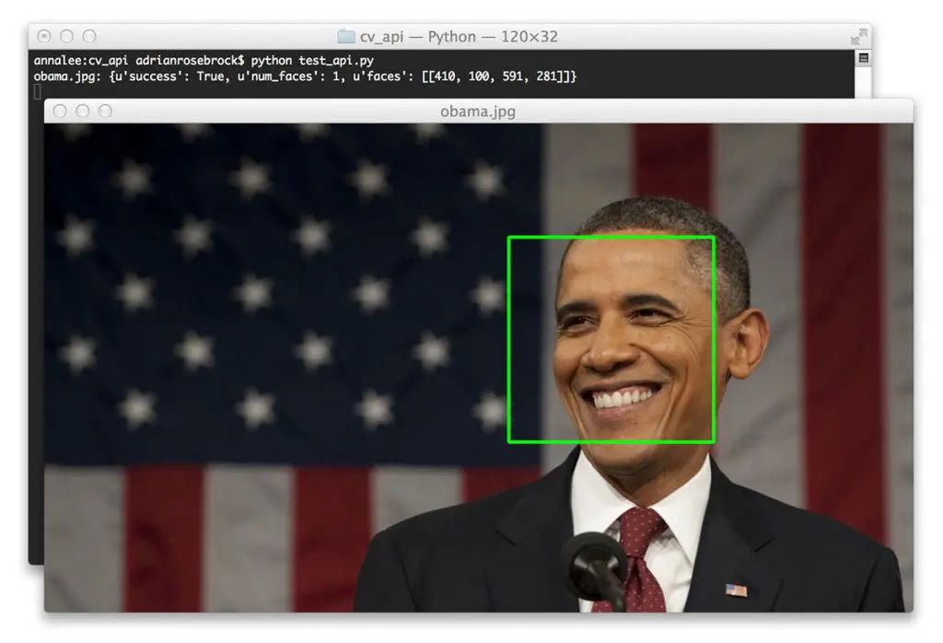



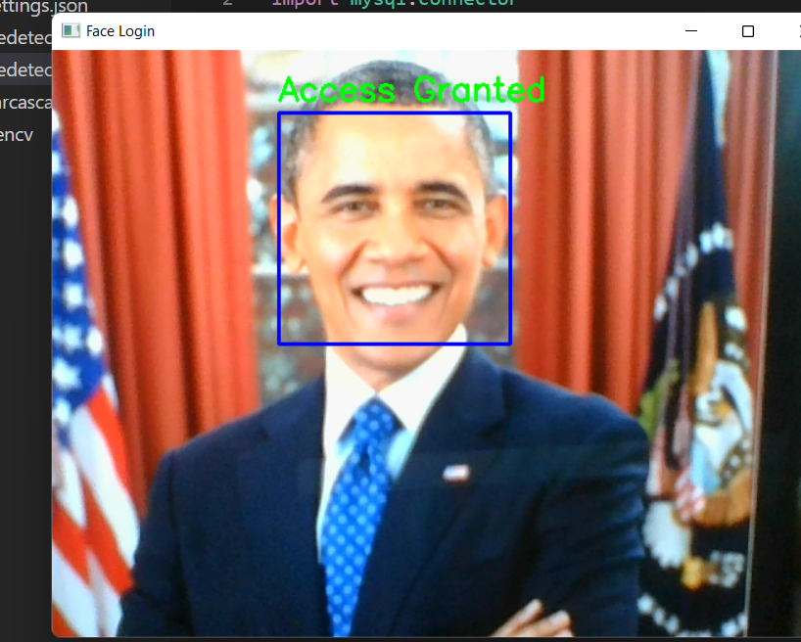

**Conclusion :**

In conclusion, the Face Login Project utilizes advanced face detection and recognition technologies to create a secure, convenient, and user-friendly authentication system. By leveraging biometric characteristics inherent in individuals' faces, the project enhances security measures, providing a robust authentication mechanism that is difficult to forge or replicate. Through the elimination of complex passwords and PINs, the project prioritizes user convenience, making the login process effortless and intuitive. Users can simply present their faces to the system for authentication, streamlining the login experience across various platforms and applications. The project's emphasis on seamless integration allows for its implementation in diverse domains, including access control systems, mobile devices, and online services. This ensures a unified and consistent user authentication experience, regardless of the specific application. Additionally, the project's adaptability and scalability enable it to cater to different industries and accommodate varying user bases. It can be customized to meet specific requirements and is capable of handling evolving needs and increasing user volumes. Furthermore, the Face Login Project contributes to the ongoing exploration and innovation of face detection and recognition technologies. It opens avenues for further advancements in biometric authentication systems, promising potential improvements in security, usability, and user experiences.